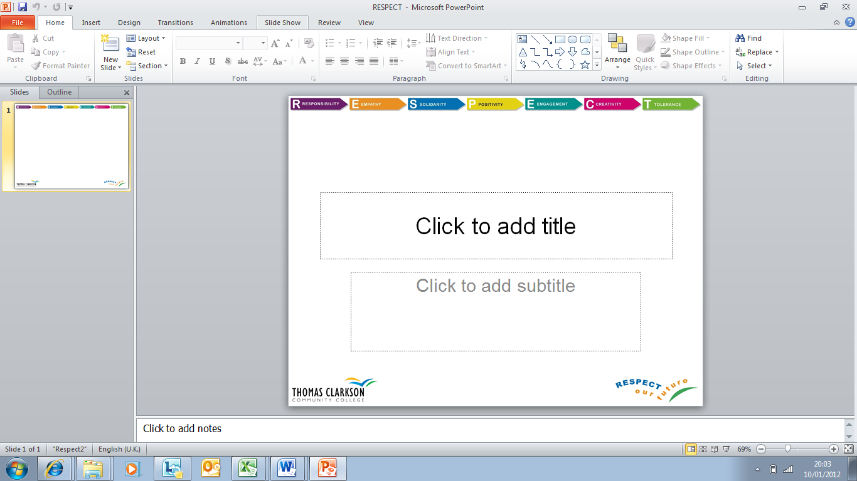
Quick Sand

Objective
To get everyone in your team from behind the line across to open area onto the platform without touching the ground.

Equipment

Towel to make platform
Frisbee sized discs to stand on

Constraints
- The discs can be used to cross the area, but once they are put on the ground they cannot be moved.
- If a disk is not being stood on, it will sink into the quicksand and is unable to be used for the rest of the journey.

