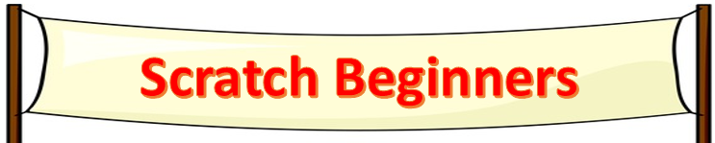

Name:

 |  | Your Marks
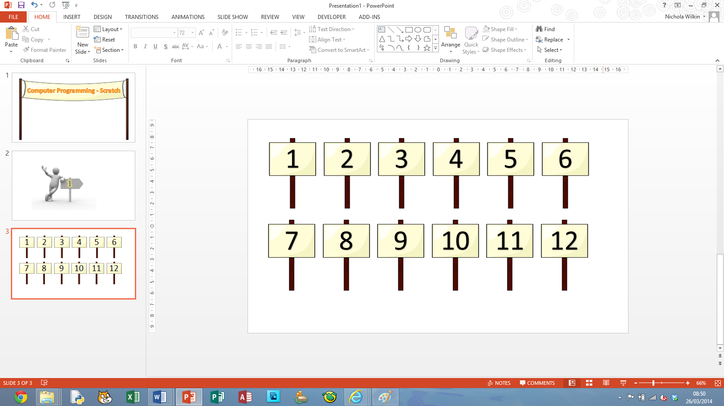 | I can import a sprite and make it move. | 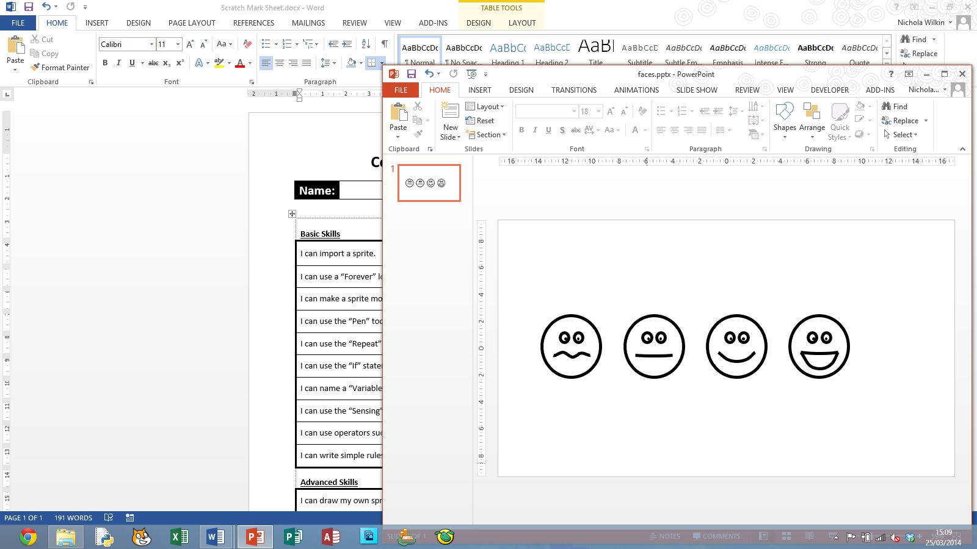
 | I can use a “Forever” and “Repeat” loops.
 | I can write instructions to draw simple shapes.
 | I can make a sprite change costume and use the “wait” function.
 | I can use the “If” statement to make a decision in a program.
 | I can use X and Y coordinates to control the position of sprites.
 | I can make improvements to games to make them more exciting.
 | I can evaluate computer games and explain what you like and think can be improved in them.
 | I can use “Variables” to keep numeric values in your game.
 | I can create a computer game where the sprites interact with each other.

Key
I still need help with this area.
I can do this but sometimes get stuck.
I can do this on my own.
I can confidently do this and feel I can even teach others this skill.

